**Module 7 – Interfacing LCD display with Arduino Uno**

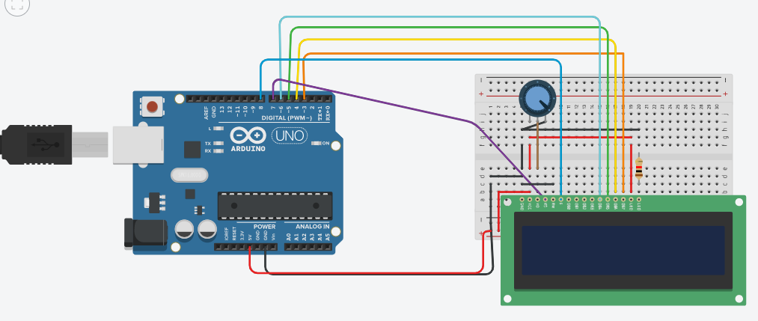

Code:

